Tahu Bulat Dadakan - Highschool Simulator Team Contract

Code of Conduct
We agree to:
- Work proactively to prevent problems before they arise.
- Keep all team members updated on project progress.
- Prioritize what’s best for the team and project as a whole.

Participation;
We will:
- Be honest, open, and respectful in all team activities.
- Ensure equal participation and consider diverse perspectives.
- Stay open to feedback and new ideas.
- Notify the team in advance if unable to meet a deadline or attend a meeting.

Communication;
We will:
- Use WhatsApp for quick updates and discussions.
- Hold weekly in-person meetings, with additional meetings as needed.
- Ensure meeting summaries are shared within 24 hours after each session.
- Keep discussions focused and productive.

Problem Solving;
We will:
- Encourage all members to contribute ideas.
- Focus on solutions rather than assigning blame.
- Support each other in overcoming challenges.

Meeting Guidelines;
We will:
- Meet in person once a week.
- Using an online platform Whatsapp for our online discussion.
- Keep meetings structured with clear agendas.

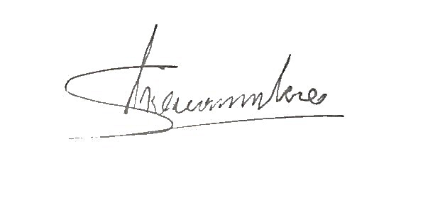  Shevchenko Saviour Matthew Poluan | Daniel Prawira | 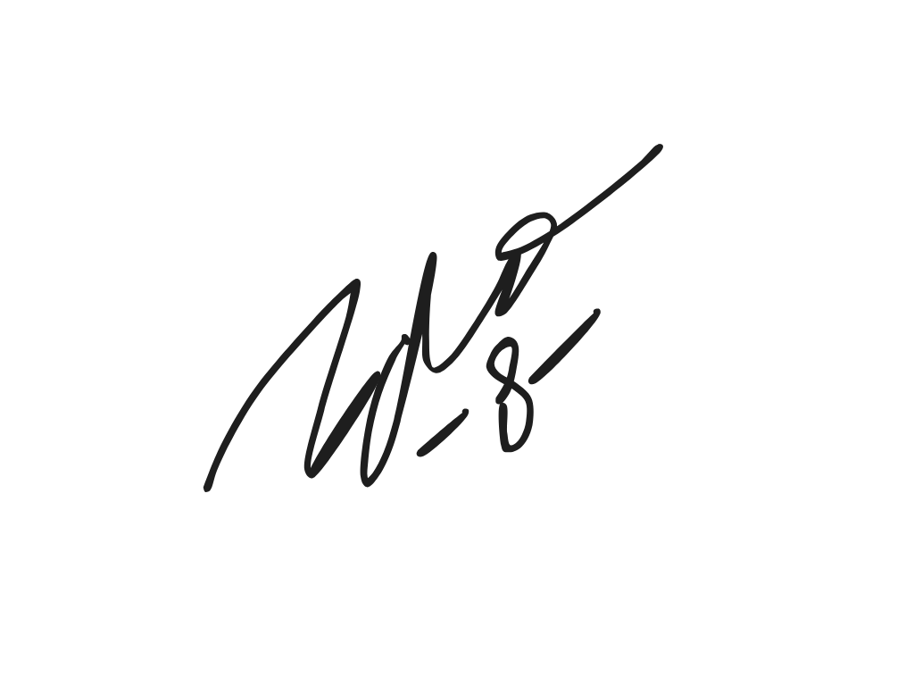  Dave Geraldo Jonathan Koro
  Joel Daniel Mark Wenas |   Syedha Audry Timothy Piri | 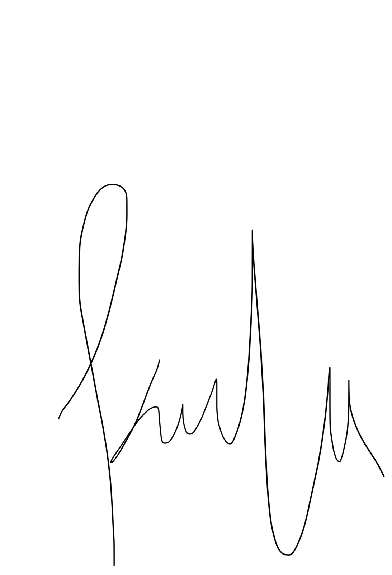  Kayla Fakhira

